**MTE 203 – Advanced Calculus**

**Fall 2022**

**MATLAB Laboratory Worksheet 3** [1]

Cameron Ritchie

Replace this text with your full name

20877299

Replace this text with your student ID

**Objectives**

1. Learn how to use symbolic variables in MATLAB.
2. Review parametrization and apply it to a real-life path-planning scenario.
3. Learn how to perform symbolic partial differentiation and integration.

For this worksheet ensure that you have the Matlab symbolic function “**syms**” at the beginning of your scripts.

**Planning the path of a drone**

1. The path of a drone needs to be designed such that it moves from one location at $a(-\frac{2}{7},-2\sqrt{3},5)$ to another location at $b(\frac{3}{7},3\sqrt{3},\frac{15}{2})$. However, there are obstacles, so it cannot travel in a straight line. The robot path planner generated the following possible path:
$$\vec{r}\left(t\right)=\frac{1}{7}t \hat{i}+\sqrt{3}t \hat{j}+\left(t^{2}-\frac{1}{2}t\right)\hat{k}$$

2. Find the limits of the parameter $t$ for the path described by $\vec{r}(t)$ starting at point $a$ and ending at point $b$, such that $t_{a}≤t≤t_{b}$

|  |  |
| --- | --- |
| $$t_{a}$$ | -2 |
| $$t_{b}$$ | 3 |

1. Write a Matlab script that shows the path of the drone using symbolic variables and the Matlab function “**fplot3**”. **Use relevant titles, labels, and a caption.**

Save your script as “**Lab3Drone1_lastname_firstname.m**”

***Insert your plot below:***

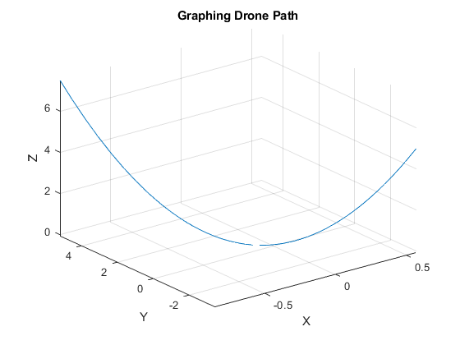

1. For the path of the drone given in Question 1, use Matlab symbolic computation to determine the following functions. Write the symbolic answer in the tables provided, a to f, and then evaluate them at $t=1$:
2. The arc length of the path

|  |  |
| --- | --- |
| **s(t) =** | (151*asinh((7*151^(1/2)*(2*t - 1/2))/151))/196 + ((2*t - 1/2)*((2*t - 1/2)^2 + 151/49)^(1/2))/4 |

1. Curvature 𝜅(𝑡)

|  |  |
| --- | --- |
| $$κ\left(t\right)=$$ | ((151*(8*t - 2)^2)/(196*((2*t - 1/2)^2 + 151/49)^3) + (2/((2*t - 1/2)^2 + 151/49)^(1/2) - ((2*t - 1/2)*(8*t - 2))/(2*((2*t - 1/2)^2 + 151/49)^(3/2)))^2)^(1/2)/((2*t - 1/2)^2 + 151/49)^(1/2) |

1. Radius of curvature 𝜌(𝑡)

|  |  |
| --- | --- |
| $$ρ\left(t\right)=$$ | ((2*t - 1/2)^2 + 151/49)^(1/2)/((151*(8*t - 2)^2)/(196*((2*t - 1/2)^2 + 151/49)^3) + (2/((2*t - 1/2)^2 + 151/49)^(1/2) - ((2*t - 1/2)*(8*t - 2))/(2*((2*t - 1/2)^2 + 151/49)^(3/2)))^2)^(1/2) |

1. Tangential component of the acceleration, $a_{T}$

|  |  |
| --- | --- |
| $$a_{T}(t)=$$ | (8*t - 2)/(2*((2*t - 1/2)^2 + 151/49)^(1/2)) |

1. Normal component of the acceleration, $a_{N}$

|  |  |
| --- | --- |
| $$a_{N}(t)=$$ | ((151*(8*t - 2)^2)/(196*((2*t - 1/2)^2 + 151/49)^3) + (2/((2*t - 1/2)^2 + 151/49)^(1/2) - ((2*t - 1/2)*(8*t - 2))/(2*((2*t - 1/2)^2 + 151/49)^(3/2)))^2)^(1/2)*((2*t - 1/2)^2 + 151/49)^(1/2) |

1. Magnitude of the acceleration,

|  |  |
| --- | --- |
|  | 2 |

Evaluating all the functions at $t=1$:

|  |  |
| --- | --- |
| $$s(1)=$$ | 1.4627 |
| $$κ\left(1\right)=$$ | 0.2852 |
| $$ρ\left(1\right)=$$ | 3.5065 |
| $$a_{T}(1)=$$ | 1.2992 |
| $$a_{N}(1)=$$ | 1.5205 |

1. Write a Matlab script using the command **subplot** to create a figure containing 5 subplots. Create one subplot of the path $\vec{r}(t)$ that spans across the upper part of the figure. Create two subplots, one for the arc length $s(t)$ and one for the curvature $κ(t)$, right below the first subplot, forming a second row. Now create two more subplots for the tangential, $a_{T}(t)$, and normal, $a_{N}(t)$ components of the acceleration on the lower part of the figure. Use a domain of $tϵ[-2, 3]$ for the plots. Include meaningful titles and label your axes. Use comments on all relevant sections of your script to indicate the different code lines used for the different parts of question 2.

Save your script as “**Lab3Drone2_lastname_firstname.m**”

***Insert your plot below:***

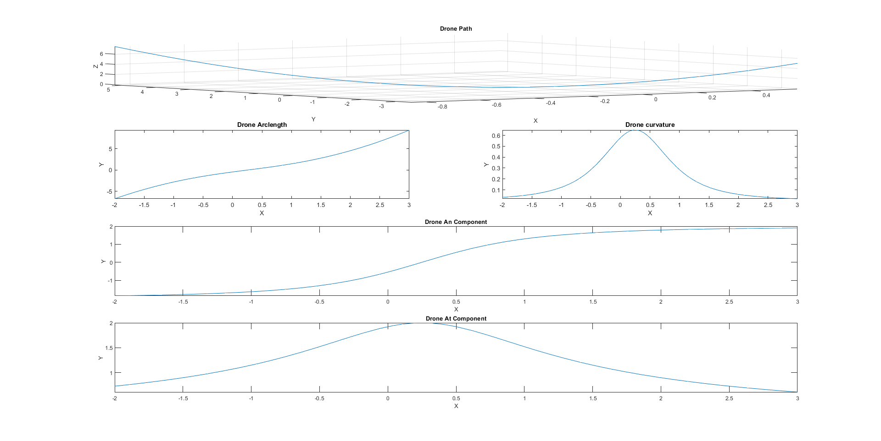

1. In physics, **jerk** or **jolt** is the rate at which an object's acceleration changes with respect to time. **Jerk** is a vector quantity (having both magnitude and direction) and it is given by,

$$\vec{j}(t)= \frac{d^{3}\vec{r}(t)}{dt^{3}}$$

A motion is considered “gentle” when the “**jerk**” remains small. Looking at the path of the drone, does the drone have a gentle motion? Briefly explain.

***Yes, the drone has gentle motion, as it is a continuous curve, not very steep in the specified range at any point. Additionally, the graphs for tangential and normal acceleration do not have a very steep slope at any point, so the jerk is likely small.***

**Multidimensional Symbolic Calculus**

1. **Symbolic Partial Differentiation:**

Consider the following function:

$$f\left(a,b,x,y\right)=a\frac{y sin\left(xy^{2}\right)}{e^{xy^{2}}+(7+x^{2})/(xy^{2})}+bxy^{2}$$

Create a Matlab script and use the MATLAB symbolic partial differentiation function “**diff**” to determine the following partial derivatives. Use comments on all relevant sections of your script to indicate the different code lines used for the different parts of question 1 below. Evaluate each one at a=1, b=4, x=5, y=2.

Save your script as “**Lab3Diff_lastname_firstname.m**”

$f_{x}$

|  |  |
| --- | --- |
| $$f_{x}\left(a,b,x,y\right)=$$ | b*y^2 + (a*y^3*cos(x*y^2))/(exp(x*y^2) + (x^2 + 7)/(x*y^2)) - (a*y*sin(x*y^2)*(y^2*exp(x*y^2) + 2/y^2 - (x^2 + 7)/(x^2*y^2)))/(exp(x*y^2) + (x^2 + 7)/(x*y^2))^2 |

|  |  |
| --- | --- |
|  | 2*b*x*y + (a*sin(x*y^2))/(exp(x*y^2) + (x^2 + 7)/(x*y^2)) + (2*a*x*y^2*cos(x*y^2))/(exp(x*y^2) + (x^2 + 7)/(x*y^2)) + (a*y*sin(x*y^2)*((2*(x^2 + 7))/(x*y^3) - 2*x*y*exp(x*y^2)))/(exp(x*y^2) + (x^2 + 7)/(x*y^2))^2 |

|  |  |
| --- | --- |
|  | 2*b*y - (a*sin(x*y^2)*(y^2*exp(x*y^2) + 2/y^2 - (x^2 + 7)/(x^2*y^2)))/(exp(x*y^2) + (x^2 + 7)/(x*y^2))^2 + (3*a*y^2*cos(x*y^2))/(exp(x*y^2) + (x^2 + 7)/(x*y^2)) - (a*y*sin(x*y^2)*(2*y*exp(x*y^2) - 4/y^3 + (2*(x^2 + 7))/(x^2*y^3) + 2*x*y^3*exp(x*y^2)))/(exp(x*y^2) + (x^2 + 7)/(x*y^2))^2 - (2*a*x*y^4*sin(x*y^2))/(exp(x*y^2) + (x^2 + 7)/(x*y^2)) + (a*y^3*cos(x*y^2)*((2*(x^2 + 7))/(x*y^3) - 2*x*y*exp(x*y^2)))/(exp(x*y^2) + (x^2 + 7)/(x*y^2))^2 - (2*a*x*y^2*cos(x*y^2)*(y^2*exp(x*y^2) + 2/y^2 - (x^2 + 7)/(x^2*y^2)))/(exp(x*y^2) + (x^2 + 7)/(x*y^2))^2 - (2*a*y*sin(x*y^2)*((2*(x^2 + 7))/(x*y^3) - 2*x*y*exp(x*y^2))*(y^2*exp(x*y^2) + 2/y^2 - (x^2 + 7)/(x^2*y^2)))/(exp(x*y^2) + (x^2 + 7)/(x*y^2))^3 |

|  |  |
| --- | --- |
|  | 2*b*y - (a*sin(x*y^2)*(y^2*exp(x*y^2) + 2/y^2 - (x^2 + 7)/(x^2*y^2)))/(exp(x*y^2) + (x^2 + 7)/(x*y^2))^2 + (3*a*y^2*cos(x*y^2))/(exp(x*y^2) + (x^2 + 7)/(x*y^2)) - (a*y*sin(x*y^2)*(2*y*exp(x*y^2) - 4/y^3 + (2*(x^2 + 7))/(x^2*y^3) + 2*x*y^3*exp(x*y^2)))/(exp(x*y^2) + (x^2 + 7)/(x*y^2))^2 - (2*a*x*y^4*sin(x*y^2))/(exp(x*y^2) + (x^2 + 7)/(x*y^2)) + (a*y^3*cos(x*y^2)*((2*(x^2 + 7))/(x*y^3) - 2*x*y*exp(x*y^2)))/(exp(x*y^2) + (x^2 + 7)/(x*y^2))^2 - (2*a*x*y^2*cos(x*y^2)*(y^2*exp(x*y^2) + 2/y^2 - (x^2 + 7)/(x^2*y^2)))/(exp(x*y^2) + (x^2 + 7)/(x*y^2))^2 - (2*a*y*sin(x*y^2)*((2*(x^2 + 7))/(x*y^3) - 2*x*y*exp(x*y^2))*(y^2*exp(x*y^2) + 2/y^2 - (x^2 + 7)/(x^2*y^2)))/(exp(x*y^2) + (x^2 + 7)/(x*y^2))^3 |

All at a=1, b=4, x=0.5, y=-1:

|  |  |
| --- | --- |
| $$f_{x}\left(1 , 4 , 0.5 , -1\right)=$$ | 3.8990 |
| $$f_{y}\left(1 , 4 , 0.5 , -1\right)=$$ | -3.8657 |
| $$f_{xy}\left(1 , 4 , 0.5 , -1\right)=$$ | -7.5932 |
| $$f_{xy}\left(1 , 4 , 0.5 , -1\right)=$$ | -7.5932 |

1. **Symbolic Integration**

In this section we will be using the symbolic Matlab function “**int**” to differentiate a vector function. However, as we did for partial differentiation, we can also partially integrate. We will do the latter during the second part of the course and for the Matlab project 1.

Consider the following scalar function:

$$g\left(t\right)=7t^{3}-3t$$

and the following vector functions:

$$u\left(t\right)=t\hat{i}-t^{2}\hat{j}+2t\hat{k}$$

$$v\left(t\right)=\hat{i}-2t\hat{j}+3t^{2}\hat{k}$$

Create a Matlab script and use the Matlab symbolic partial differentiation function “**int**” to determine the following integral,

$$F\left(t\right)=\int{\left[5g\left(t\right)(u\left(t\right)+v\left(t\right))\right]dt}$$

Use comments on all relevant sections of your script to indicate the different code lines used for the different parts of question 2 below.

Save your script as “**Lab3Int_lastname_firstname.m**”

1. Using Matlab symbolic calculations, re-write the integrand of $F\left(t\right)$ as a function of the parameter $t$

|  |
| --- |
| $$F\left(t\right)=\int{([1 - t*(- 35*t^3 + 15*t), t^2*(- 35*t^3 + 15*t) - 2*t, 3*t^2 - 2*t*(- 35*t^3 + 15*t)])dt}$$ |

1. Perform the integration and write each one of the three scalar components ($F_{i}, F_{j}, F_{k}$) of the resulting vector function $\vec{F}\left(t\right)=F_{i} \hat{i}+F_{j} \hat{j}+F_{k} \hat{k}$.

|  |  |
| --- | --- |
| $$F_{i}=$$ | 7*t^5 - 5*t^3 + t |

|  |  |
| --- | --- |
|  | -(t^2*(70*t^4 - 45*t^2 + 12))/12 |

|  |  |
| --- | --- |
|  | 14*t^5 - 9*t^3 |

**LEARN Submission:**

Upon finishing your worksheet, you should have generated the following *.m files:

1. Lab3Drone1_< lastname_firstname >.m
2. Lab3Drone2_< lastname_firstname >.m
3. Lab3Diff_< lastname_firstname >.m
4. Lab3Int_< lastname_firstname >.m

**Make sure that you submit two files:**

1. Your MatLab Laboratory Worksheet 3 file saved as a **pdf** and named as **W3_name_lastname.pdf**
2. All associated *.m files listed above inside **one single zipped file** named **W3_code_name_lastname.zip**

**IMPORTANT:**

To submit your files, please use the “**MTE 203 Matlab Worksheet 3 Dropbox**” in LEARN. **Please note that the dropbox will accept only one submission.**

1. Please note that this Laboratory Worksheet must reflect your individual work and that submissions are individual